Life Cycle of a Star - Worksheet

A STAR IS BORN – STAGES COMMON TO ALL STARS
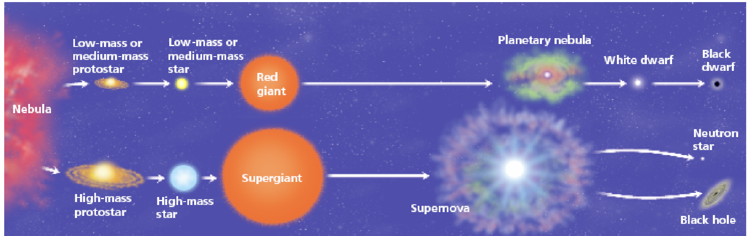
All stars start as a nebula. A nebula is a large cloud of gas and dust. Gravity can pull some of the gas and dust in a nebula together. The contracting cloud is then called a protostar. A protostar is the earliest stage of a star’s life. A star is born when the gas and dust from a nebula become so hot that nuclear fusion starts. Once a star has “turned on” it is known as a main sequence star. When a main sequence star begins to run out of hydrogen fuel, the star becomes a red giant or a red super giant.

THE DEATH OF A LOW OR MEDIUM MASS STAR
After a low or medium mass or star has become a red giant the outer parts grow bigger and drift into space, forming a cloud of gas called a planetary nebula. The blue-white hot core of the star that is left behind cools and becomes a white dwarf. The white dwarf eventually runs out of fuel and dies as a black dwarf.

THE DEATH OF A HIGH MASS STAR
A dying red super giant star can suddenly explode. The explosion is called a supernova. After the star explodes, some of the materials from the star are left behind. This material may form a neutron star. Neutron stars are the remains of high-mass stars. The most massive stars become black holes when they die. After a large mass star explodes, a large amount of mass may remain. The gravity of the mass is so strong that gas is pulled inward, pulling more gas into a smaller and smaller space. Eventually, the gravity becomes so strong that nothing can escape, not even light.

Question Sheet
Just like living things and humans, stars have a life cycle, which consists of birth, growth, development, middle age, old age, and death. The life cycle of a star spans over billions of years.

Section One - Sequencing
The stages below are not in the right order. Number the stages in the correct order.

_____ The star begins to run out of fuel and expands into a red giant or red super
giant.

_____ Stars start out as diffused clouds of gas and dust drifting through space. A single
one of these clouds is called a nebula

_____ What happens next depends on the mass of the star.

_____ Heat and pressure build in the core of the protostar until nuclear fusion takes place.

_____ The force of gravity pulls a nebula together forming clumps called protostars.

_____ Hydrogen atoms are fused together generating an enormous amount of energy igniting the star causing it to shine.
Section Two - Vocabulary
Match the word on the left with the definition on the right.

____ black dwarf e. star left at the core of a planetary nebula

____ white dwarf g. a red super giant star explodes

____ nebula c. what a medium-mass star becomes at the end of its life

____ protostar b. a large cloud of gas or dust in space

____ supernova a. exerts such a strong gravitational pull that no light escapes

____ neutron star d. the earliest stage of a star ’s life

____ black hole f. the remains of a high mass star

Section Three – Understanding Main Ideas - Low Mass Star

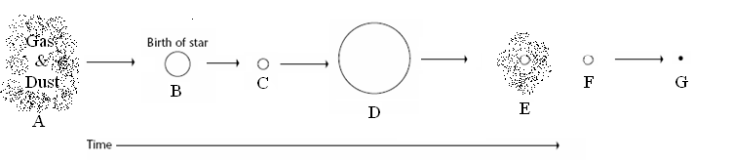

____ 1. Red giant
____ 2. Where fusion begins
____ 3. Nebula
____ 4. Black hole
____ 5. The stage the sun is in
____ 6. White dwarf
____ 7. Planetary Nebula

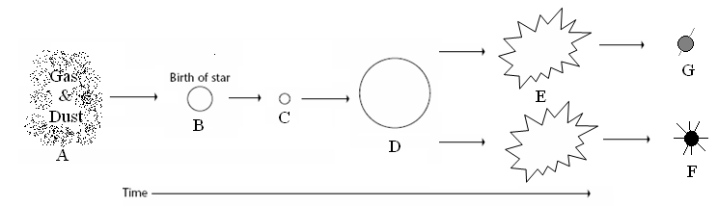
Section Four – Understanding Main Ideas - High Mass Star

____ 1. Black Hole
____ 2. Supernova
____ 3. Protostar
____ 4. Gravity causes this to condense into a protostar
____ 5. Main sequence star
____ 6. When a star begins to run out of fuel and grows larger
____ 7. Neutron star

