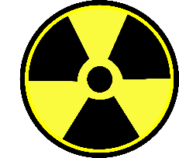
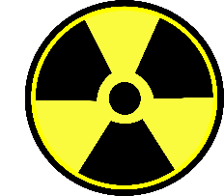
Radioactivity
Watch the following video to help you answer the following questions.
https://www.youtube.com/watch?v=dY10s71rv80

- What is radioactivity?

- What scientist was first to use the word radioactivity?

- What causes a nucleus to become unstable?

- What are the three types of radiation?

- What is meant by half life?

- What are artificial radionuclides and where do we use them?

- What are natural radionuclides and where do they occur?

Types of Radiation
https://www.youtube.com/watch?v=27qSAqafQ6o

- What is Alpha radiation? What element emits it?

- How far does Alpha radiation penetrate the skin? When could it be dangerous?

- What particles emit Beta radiation? How far can they penetrate into the skin?

- What could happen if you try to shield yourself from Beta radiation?

- Where do Gamma rays originate? Why are they dangerous, why might they not be dangerous?

