**Semester Test Review Packet Name_______________**

**Universal Gravitation**

1. An orbiting satellite is a projectile upon which the only force is gravity.

a. True b. False

1. All objects on Earth's surface attract each other with the same amount of force of gravitational attraction.

a. True b. False

1. The path of planets around the Sun can best be described as _____.

a. a square b. a parabola

c. elliptical in shape d. circular in shape

e. Nonsense! Very little is known about the shape of the planets' orbits.

1. Kepler's second law of planetary motion is often called the law of equal areas. Which one of the following statements would be an extension of this law?

a. Any given planet will travel fastest along its orbital path when it is closest to the Sun.

b. A planet would move at the same speed at all times during its orbit about the Sun.

c. The longer the imaginary line from a planet to the Sun is, the greater the speed of the planet will be.

d. When two different planets lie along the same imaginary line from planet to the Sun, their speeds are equal.

e. The length of an imaginary line drawn from a planet to the Sun multiplied by the period is equal to the planet's area.

1. One could reason from Kepler's third law of planetary motion that _____.

a. an object that is further from the Sun would have a greater surface area

b. an object that is further from the Sun would have a greater orbital period

c. an object that is closer to the Sun would take a longer amount of time to orbit

d. an object that is closer to the Sun would appear bigger when viewed from Earth

1. Kepler's first law of planetary motion states that ____. Choose one.

a. the Sun is at the center of the solar system

b. gravity provides the force that holds the planets in orbit about the Sun

c. planets orbit the Sun in circular orbits, with the Sun located at the center

d. planets orbit the Sun in elliptical orbits, with the Sun located at one focus

1. According to the Law of Universal Gravitation, the force of gravitational attraction between two objects is directly proportional to the _____ ...

a. product of the objects' masses

b. the square of the masses of the objects

c. the product of the radius of each object

d. the square of the average radius of the objects

e. the square of the separation distance between the two objects

1. (continuing from previous problem) ... and inversely proportional to the _____.

a. product of the objects' masses

b. square of the masses of the objects

c. product of the radius of each object

d. square of the average radius of the objects

e. square of the separation distance between the two objects

1. If the Earth were twice as massive but had the same radius, then what would happen to the strength of the gravitational acceleration upon Earth's surface?

a. It would be double the size. b. It would be one-half the size.

c. It would be quadruple the size. d. It would be one-fourth the size

1. Two objects have a force of gravity between them of 16N. What is the new force of gravity if the distance between them is doubled?

a. 32N b. 4N

c. 8N d. 64N

1. Which of the following factors affect the force of gravitational attraction between the Sun and a planet? Select all that apply.

a. The mass of the Sun.

b. The mass of the planet.

c. The period of orbit of the planet.

d. The distance between the Sun and the planet.

e. The speed at which the planet moves along its orbital path.

1. The significance of the word *universal* as used in Newton's Law of Universal Gravitation is that _____.

a. the law existed since the universe began.

b. the law explains how the universe is held together.

c. the law explains the motion of all large objects in the universe.

d. the law applied universally to all objects, not just to planets and the sun.

1. The value of G is ______. This explains why ______.

a. large; the planets are as massive as they are

b. small; people are at rest on Earth instead of in orbit about the Earth

c. small; two nearby students do not exhibit a significant gravitational attraction

d. large; a planet with as much mass as the Earth can still be held in orbit about the Sun

1. Orbiting astronauts on the space shuttle do not have weight in space because _____.

a. there is no gravity in space

b. there is no air resistance in space

c. the food is terrible and they work all the time

d. there are no scales in space to weigh themselves

e. ... nonsense! The astronauts do have weight in space.

1. A person will feel weightless whenever ____. Select all that apply.

a. they are in a free-fall environment

b. the air resistance acting upon their body is negligible

c. they weigh nothing due to reduced gravitational forces upon their body

d. there is no support force to balance the force of gravity upon their body

e. they drink large quantities of soda pop and the carbonation makes them float

16. Define tangential velocity?

17. What is the equation to calculate the force of gravity between two objects?

18. What are the units?

19. How is the force of gravity affected when distances between two objects is doubled?

a. Tripled?

20. If the gravitational force of the sun on the planets suddenly disappeared, in what kind of paths would the planets move?

21. Two bowling balls each have a mass of 6.8 kg. They are located next to each other with their centers .218 m apart. What gravitational force do they exert on each other?

22. Where in an elliptical orbit is the speed of a satellite maximum? b. Where is it minimum?

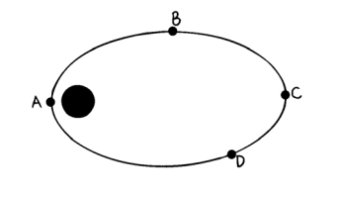23. This question reviews several concepts of mechanics. A satellite travels the elliptical path as shown below. At which of the positions A through D does the satellite experience the maximum:

a gravitational force?

b. Speed?

c. Kinetic energy?

d. Gravitational potential energy?

e. Acceleration?

24. Use Newton's law of universal gravitation to determine the force of gravitational attraction between two students of mass 50 kg and 100 kg if they are seated in their chairs a distance of 3 m apart

Equation Math Answer with Units

1. Find the acceleration due to gravity on the planet Saturn. Mass of Saturn is 5.683 × 10^26 kg radius is 5.82 x 10 ^7 m.

Equation Math Answer with Units

1. Determine the orbital speed of Mercury as it orbits about the Sun. (GIVEN: Msun = 1.99 x 1030 kg and Mercury-sun distance = 6.0 x 10^ 10 m)

Equation Math Answer with Units

1. The moon revolves in its orbit at a distance of 3.84 x 108 meters from the center of the Earth. The mass of the Earth is 5.98 x 1024 kilograms. What is the tangential velocity of the moon in its orbit?

Equation Math Answer with Units

a. If the moon were farther from the Earth, would its tangential velocity increase, decrease, or remain constant? Why?

b. If the moon were more massive, would its tangential velocity increase, decrease, or remain constant? Why?

**Electrostatics**

1. Which force- gravitational or electrical-repels as well as attracts?
2. Gravitational forces depend on the property called mass. What comparable property underlines electrical forces?

30. How do protons and electrons differ in their charge?

31. How do like charges behave?

32. How do unlike charges behave?

33. How is Coulomb’s law similar to Newton’s law of gravitation?

34. In a grain elevator on Farmer Judd’s farm, kernels of grain become electrically charged while falling through the elevator. One kernel of grain is charged with +2.0 x 10-16 C, while another holds +5.0 x 10-16 C. Calculate the electrostatic force between the kernels when they are separated by .05 m.

1. Which one of these statements is true of a neutral or uncharged object?
   1. A neutral object does not have any charged particles in it.
   2. b. A neutral object does not have any protons or electrons in it.
   3. c. A neutral object has equal numbers of protons and electrons.
   4. d. The protons and electrons in a neutral object do not have any charge.
2. A positively charged object contains _____.

a. only protons

b. only electrons

c. more protons than electrons

d. more electrons than protons

1. **Type:** M **Level;** 1 **Graphic:** **Text:** D/18.D **Answer:** DSuppose an electroscope has a neutral charge. A negatively charged rod is brought close to the sphere of the electroscope but does not touch it. Which of the following statements best explains what happens?
2. The leaves of the electroscope spread out because of conduction.
3. The charges on the electroscope spread out because they have positive charges that repel each other.
4. The leaves of the electroscope spread out because they have positive charges that repel each other.
5. The leaves of the electroscope spread out because they have negative charges that repel each other.
6. Which one of the following statements describes how a neutral object becomes charged negatively during an electrostatic experiment?
   1. Rubbing or touching creates positive energy from nothing.
   2. Rubbing or touching creates electrons at a location where they did not previously exist.
   3. Protons are transferred to the object when rubbed with or touched to another object.
   4. Electrons are transferred to the object when rubbed with or touched to another object.
7. Which statement describes the difference between an insulator and a conductor?
   1. Insulators gain electrons; conductors lose electrons.
   2. Insulators can gain or lose electrons; conductors can only lose electrons.
   3. Electrons can flow freely through insulators; they do not move through conductors.
   4. Electrons can flow freely through conductors; they do not move through insulators.
8. 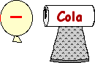A negatively charged balloon is brought near to a metal pop can as shown in the diagram at the right. Which statement describes what happens as the balloon approaches the can?
   1. Electrons move from the balloon to the can.
   2. Electrons move from the can to the balloon.
   3. Electrons within the can move away from the balloon's side.
   4. Electrons within the can move towards from the balloon's side.
9. 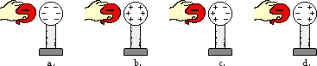A negatively charged balloon is brought near a neutral, conducting sphere. Which diagram below depicts the arrangement of charge on the neutral sphere?
10. 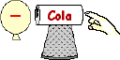A negatively charged balloon is held near a neutral, aluminum can. The opposite side of the can is touched. When touched, electrons move _____.
    1. from the can to the hand
    2. from the hand to the can
    3. from the balloon to the can
    4. from the balloon to the can to the hand
11. A positively charged balloon is brought near a neutral, conducting sphere. This causes the sphere to be _____.
    1. grounded
    2. polarized
    3. charged negatively
    4. charged positively
12. The law of conservation of charge states that charge is neither created nor destroyed. Which of the following statements is consistent with this law?
    1. All charging methods involve the transfer of electrons between two objects.
    2. When charging an object by friction, the energy of rubbing is transformed into charge.
    3. When charging an object by conduction, the act of touching creates electrons upon the touched object.

A neutral aluminum pie plate is brought near a negatively charged foam square. The top of the aluminum pie plate is touched by a hand and becomes charged. The charge on the plate is?

a. positive

b. negative

c. neutral

d. Nonsense! This process would never charge the pie plate.

1. The electrical force between two objects is 36 N. If the distance between the objects is doubled, the force between them will be ___.

a. 4 N

b. 9 N

c. 12 N

d. 18 N

e. 36 N

1. Two neutral conducting pop cans are touching each other. A positively-charged balloon is brought near one of the cans. The cans are separated while the balloon is nearby. After the balloon is removed can Y is ____.



a. positively-charged

b. negatively-charged

c. neutral

d. much more massive

1. When rubber and fur are rubbed together, electrons are removed from the fur and are placed on the rubber rod. What is the charge on the fur now?
2. positive
3. negative
4. neutral
5. gravitational
6. A 4 C charge and an 8C charge are two meters apart. What is the force between them?
7. If two charges experience a force of 10N, and both charges are 3C, what is the distance between them?

51. A 1x10^-6 C charge and an 2x10^-4 C charge are 4x10^-8 meters apart. What is the force between them?

**Electricity**

52. What is Ohm’s law?

53. If the resistance of a circuit remains constant while the voltage across the circuit decreases to half its former value, what change occurs in the current?

54. Which of these is a unit of power and which is a unit of electrical energy: a watt, a kilowatt, and a kilowatt-hour?

55. How many amperes flow through a 60-watt bulb when 120 volts are impressed across it?

56. A motor with an operating resistance of 32 ohms is connected to a voltage source. The current I the circuit is 3.8

What is the voltage of the source

57. How much current moves through your fingers (resistance: 1200 ohms) if you touch them to the terminals of a 6-volt battery?

Put the letter of the best answer in the blank. Use these answers for all of the questions:

1. Series b. Parallel c. Both Series and Parallel d. Neither Series nor Parallel
2. _______ Potential difference and current are directly related.
3. _______ A(n) _____ circuit has only one path.
4. _______ A(n) _____ circuit has multiple paths.
5. _______ The total resistance decreases as more resistors are added.
6. _______ The potential difference(v) is the same through all resistors.
7. _______ The potential difference through all the resistors adds up to the total.
8. _______ The current is the same through all resistors.
9. ________ When one light goes out, the rest stay on in a _____ circuit.
10. _______ When one light goes out, so do the rest in a ____ circuit.
11. _______ Current and total resistance are inversely related.
12. ________ The individual resistors add up to the total resistance.
13. ________ The current through all the resistors adds up to the total.
14. _______ The voltage drop is the same through the different branches of the circuit.
15. _______ The total (equivalent) resistance is smaller than the resistance of any of the resistors.

72. In a circuit, voltage and current are

* 1. directly proportional,
  2. inversely proportional,
  3. not proportional.

1. What is the resistance of a toaster that uses 4.00 A on a 110 V line?
   1. 27.5 Ω b. 55.0 Ω c. 110 Ω d. 440 Ω
2. According to Ohm’s Law, what effect will cutting the resistance have on the current?
   1. increase the current
   2. decrease the current
   3. not affect the current
3. What happens to the total resistance in a series circuit when more resistors are added?
   1. Increases
   2. Decreases
   3. Stays the same
4. If the power source is set at 6V and R is 2 ohms, the current =___________
   1. 12A
   2. 3A
   3. 12watts
   4. 3watts
5. V=5volts, R= 10 ohms, I= ____________.
   1. .5 A
   2. 50 A
   3. .5 watts
   4. 5 watts
6. If a 100 watt light bulb is left on 24 hours a day for 10 days and electricity costs $.10 per kwh, how much will it cost
   1. $2.40
   2. $2400
   3. $1.20
   4. $3.40
7. Calculate the resistance of the filament in a lightbulb that carries 0.4 A when 3.0 V is impressed across it.
8. Calculate the current in a 140-W electric blanket connected to a 120-V outlet.
9. An 8 amp electric heater operates on a 120V outlet. What is the power of the device?
   1. Calculate the energy used for 4 hours.

b. Calculate the cost to operate the electric heater if the cost per kilowatt-hour is 8 cents.

1. Distinguish between a series circuit and a parallel circuit?
2. If three lamps are connected in a series to a 6 volt battery, how many volts are impressed across each lamp?
3. If three lamps are connected in parallel to a 6-volt battery, how many volts are impressed across each lamp?
4. What happens to the total circuit resistance when more devices are added to a series circuit? To a parallel circuit?
5. What is the total resistance of a pair of 8-ohm resistors in series? In parallel? Draw a schematic diagram of each.

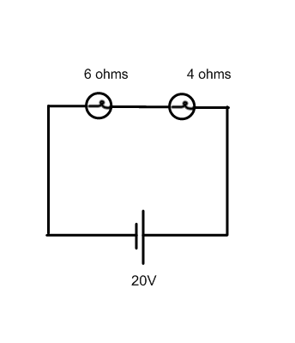

|  |  |  |  |
| --- | --- | --- | --- |
|  | R | I | V |
| **R1** | 6 |  |  |
| **R2** | 4 |  |  |
| Total |  |  |  |

|  |  |  |  |
| --- | --- | --- | --- |
|  | R | I | V |
| **R1** |  |  |  |
| **R2** |  |  |  |
| **Total** |  |  |  |

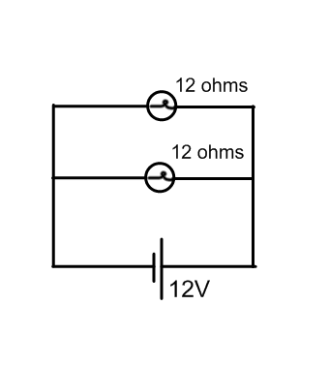

**Electromagnetism**

87. What is a magnetic domain?

88. Why will dropping or heating a magnet weaken it?

89. What is the right hand rule used for?

90. For each situation below, a current carrying wire runs through a magnetic field. Draw and label the direction of the magnetic force exerted on the wire.

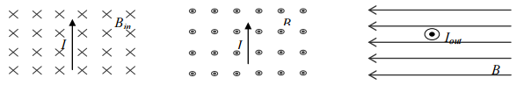

91. A 6.0 V battery is connected to a wire of length .15 m and resistance of .10 Ω. Calculate the current flowing through the wire.

b) If the magnetic field is .025 T, calculate the magnetic force exerted on the wire.

92. A magnet moved into a coil of wire will induce voltage in the coil. What is the effect of moving a magnet into a coil with more loops?

93. Define electromagnetic induction.

94. What is a generator?

95. What is a motor?

96. What would be needed to build each?

97. A motor is characterized by three main ingredients: magnetic field, moving charges, and magnetic force. What are the three main ingredients that characterize a generator?

98. How can a change in voltage in a coil of wire (the primary) be transferred to a neighboring coil of wire (the secondary) without physical contact?

99. How does the relative number of turns on the primary and the secondary coil in a transformer affect the step-up or step-down voltage factor?

100. If the number of secondary turns is 10 times the number of primary turns, and the input voltage to the primary is 6 volts, how many volts will be induced in the secondary coil?

101. If the north pole of one magnet is brought near the south pole of another magnet, the poles will

A) attract each other

B) repel each other

C) not interact with each other at all

102. If you break a bar magnet if half, each half

A) Contains one magnetic pole

B) becomes a bar magnet with 2 poles

C) becomes unmagnetized

103. If you put a small compass in a magnetic field, the compass will

A) swing in any random direction

B) always line up parallel to the magnet

C) line up with the magnetic field lines

104. Magnetic field strength is

A) Strongest close to a magnets poles

B) strongest far from a magnet

C) constant everywhere around a magnet

105. Magnetic forces are produced by

A) charges at rest

B) moving charged particles

C) moving particles of earth

D) moving particles

E) None of the above

106. Magnetic domains are

A) clusters of atoms randomly aligned

B) blocks of material

C) regions that may or may not be magnetized

D) regions of atoms magnetically aligned

107. When current passes through a wire, a magnetic field is created around the wire only if

A) the current comes from a battery

B) the wire is absolutely straight

C) the wire is curved in a loop

D) Nonsense! A magnetic field is always created around wire having a current

108. A wire carrying a current is bent into a loop. At equal distances from the wire, the magnetic field is

stronger

A) inside the loop

B) outside the loop

C) just loopy

109. The reason a motor works is that the

A) Battery pushes a loop around in the field

B) magnet attracts stationary electrons in the wire

C) magnetic field exerts forces on moving electrons in the loop of wire

110. The source of all magnetism is

A) tiny pieces of iron

B) tiny domains of aligned atoms

C) ferromagnetic materials

D) moving electric charges

111. The device that converts mechanical energy into electrical energy

a) electric motor

b) transformer

c) electric generator

d) none

112. The device that converts electrical energy into mechanical energy

a) electric motor

b) transformer

c) electric generator

d) none

113. The device that can increase or decrease the voltage

a) electric motor

b) transformer

c) electric generator

d) none

114. The process of creating electricity by changing the magnetic field around a coil of wire

a) conduction

b electromagnetic coupling

c) electromagnetic induction

d) none

115. When creating electricity with a magnet and a coil of wire what is one way to increase the amount of electricity produced

a) move the magnet more slowly

b use more resistance in the coil of wire

c) move the magnet in a direction parallel to the coil of wire

d) increase the number of loops of wire

For each of the following determine the direction of the third.

B ( magnetic field )

v ( movement of the charge )

F ( force )

116) B: north

v: east

F:

117) B:___________

v: into the paper

F: west

118) B: South

v:

F: out of the paper

For each of the following calculate the missing quantities for a transformer: Show all work.

119) Voltage in: 120 volts

Turns on the primary: 100 turns

Turns on the secondary: 50 turns

Voltage out:____________

120) Current in: 2A

Voltage in: 120 volts

Turns on the primary: 60 turns

Turns on the secondary: 80

Voltage out:___________

Current out:___________

**Waves**

121. Label and distinguish among these different parts of a wave: amplitude, crest, trough, and wavelength.

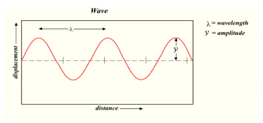

122. What is the frequency if the time in the drawing represents 2 seconds?

123. What is the period?

124. Distinguish between the period and the frequency of a vibration or a wave. How do they relate to one another?

125. Does the medium in which a wave travels move along with the wave itself? Defend your answer.

126. How does the speed of a wave relate to its wavelength and frequency?

127. As the frequency of sound is increased, does the wavelength increase or decrease? Give an example

128. Distinguish between a transverse wave and a longitudinal wave. Indicate the interval(s) which represents one full wavelength on both types of waves.

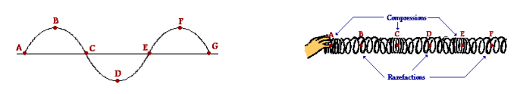

129. New York’s 300-m high Citicorp tower oscillates in the wind with a period of 6.80 s. Calculate its frequency of vibration.

130. What is the source of all sounds?

131. How does pitch relate to frequency?

132. Light can travel through a vacuum, as is evidenced when you see the sun or the moon. Can sound travel through a vacuum also? Explain why or why not.

133. Why does sound travel faster in solids and liquids than in gases?

134. What is the wavelength, in meters, of the sound produced by a tuning fork that has a frequency of 320 Hz? The temperature of the air is 15 ºC.

135. Sound waves travel at approximately 340 m/s. What is the wavelength of a sound with a frequency of 20 Hz (the lowest note we can hear as a sound)?

a. What is the wavelength of a sound with a frequency of 20 kHz (the highest note we can hear)?

136. Suppose you wish to produce a sound wave that has a wavelength of 1 m in room temperature air. What would its frequency be?

137. A tuning fork is used to produce sound waves with a frequency of 440 hertz. The waves travel through the air at 344 m/s. What changes when a different tuning fork is used to produce sound waves of 512 hertz?

* 1. The velocity of the sound will increase
  2. The velocity of the sound will decrease
  3. The wavelength of the sound will increase
  4. The wavelength of the sound will decrease

1. Changing which of the following will affect the velocity of a wave?
   1. Frequency
   2. Wavelength
   3. Amplitude
   4. Medium
2. Astronauts on the Moon would not be able to hear a landslide because:
   1. The lunar dust deadens sounds.
   2. There is no air in space to carry the sound.
   3. The magnetic field of the Moon is too weak to carry sound.
   4. Intensive sunlight destroys sound waves.
3. 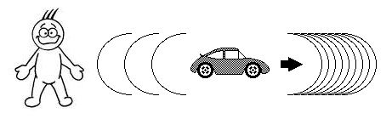A man is standing by the side of the road when a Porsche 911 drives by, blowing its horn. The Porsche is driving away from the man on the ground. Compared to the frequency of the sound that the driver of the Porsche hears, the man standing on the ground hears a sound with:
   1. The same wavelength.
   2. More variation in tone.
   3. Greater amplitude.
   4. A lower frequency.

141. The distance between two points on a wave that have the same amplitude and motion is called

a) Period

b) Frequency

c) Amplitude

d) Wavelength

142. The diagram to the right represents a standing wave on a spring. How many antinodes are there in this wave system?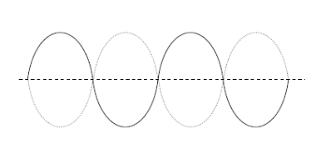

A) 5

B) 2

C) 4

D) 3

143. As the volume of a sound is increasing, what property of the sound wave is increasing?

A) Amplitude

B) Wavelength

C) Frequency

D) Speed

144. Which of the following mediums is not able to transmit sound waves?

A) Vacuum

B) Water

C) Air

D) Steel

145. As the pitch of a sound is increasing, what property of the sound wave is increasing?

A) Amplitude

B) Wavelength

C) Frequency

D) Speed

Use the diagram at the right to answer the following questions.

146. What is the period of the wave in seconds?

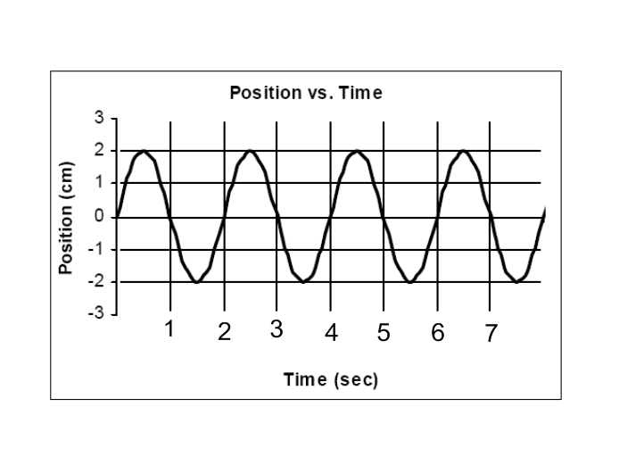A) 1

B) 2

C) 3

D) ½

147. What is the amplitude of the wave in cm?

A) 1

B) 2

C) 3

D) 4

148. What is the frequency of the wave?

A) .5

B) 1

C) 2

D) 3

149. If the wavelength of this wave was 5m, then what would its velocity be?

A) 5m/s

B) 2.5m/s

C) 10m/s

D) can’t be determined

150. A 4-m long string, clamped at both ends, vibrates at 200 Hz. If the string resonates in 4 segments(anti-nodes), what is the speed of transverse waves on the string?

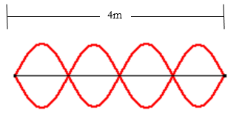A) 100 m/s

B) 133 m/s

C) 267 m/s

D) 328 m/s

E) 400 m/s

A wave is established in a rope. The diagram below represents a *snapshot* of the pattern in the rope at a given instant in time.

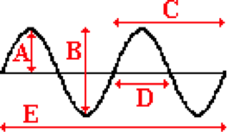

151, Which of the given distances represent the wavelength of the wave?

152. Which of the given distances represents the amplitude?

153. Which one of the following regions of the electromagnetic spectrum consists of waves with the longest wavelength?

a. Infrared

b. Radio waves

c. Ultraviolet

d. Visible light

154. Which one of the following regions of the electromagnetic spectrum consists of waves with the lowest frequency?

a. Infrared

b. Radio waves

c. Ultraviolet

d. Visible light

155. Which is the proper ordering of the infrared, microwave, ultraviolet and visible regions of the electromagnetic spectrums, from longest to shortest wavelength?

a. microwave, infrared, visible, ultraviolet

b. infrared, visible, ultraviolet, microwave

c. ultraviolet, microwave, visible, infrared

d. infrared, ultraviolet, microwave, visible

e. ultraviolet, visible, infrared, microwave

156. Which one of the following traits or behaviors is an indicator that light is a wave?

a. Light can travel through the vacuum of space.

b. Light waves can interfere with themselves.

d. Light particles possess mass.

d. Light travels at enormous speeds.

157. Which one of the following traits or behaviors is an indicator that light is a particle?

a. Light can travel through the vacuum of space.

b. Light waves can interfere with themselves.

d. Light particles possess mass.

d. Light travels at enormous speeds.

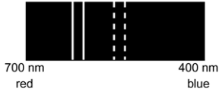158. The dashed lines on the figure show the stationary wavelengths of light coming from a star. The solid lines are the observed wavelengths. What best describes the motion of the star?

a. The star is moving toward earth.

b. The star is moving away from earth.

d. The star is not moving.

d. It cannot be determined which direction the star is moving.

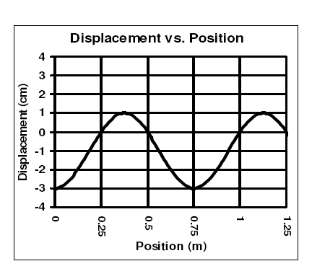

159. What is the wavelength of this wave?

160. What is the amplitude of this wave?

161. If this wave was traveling at a speed of 100m/s, estimate the frequency of the wave.

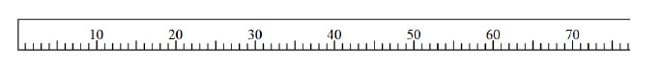

f = 100hz

The standing wave shown above is 60cm long.

What is the wavelength of the wave?

How many anti-nodes are there?

What harmonic is this?

What is the fundamental frequency?

162. List the types of electromagnetic waves in order from the lowest frequencies to the highest frequencies.

163. What do all of these waves have in common?

164. What are their differences?

165. What is the speed of electromagnetic waves?

166. What is a red shift from a star, and how does it provide evidence for the big band?

167. How do the frequencies of infrared, visible, and ultraviolet light compare?

168. Different bells and tuning forks have their own natural vibrations and emit their own tones when struck, How is this analogous to light?

169. An infrared wave has a wavelength of 7.1 x 10-7 m. What is its frequency?

170. What is the wavelength of a 512 Hz sound wave traveling at 345 m/s in air?

171. What evidence can you cite to support the idea that light can travel through a vacuum?

172. List the order of the colors in the spectrum.

a. What is the low energy end?

b. What is the high energy end?

173. What colors of spots are lit on a television tube to give it full color?

174. What colors of ink are used to print full-color pictures in books and magazines?

175. Bart uses a helium-neon laser to align his telescope. The laser emits red light with a wavelength of 633 nm. What is the wavelength of the helium-neon laser in meters?

a. How much energy is given off by each photon of laser light?

176. The KRRO broadcasts at 103.7 MHz (FM). What is the frequency of the KRRO’s broadcast in Hz?

a. Calculate the wavelength of the KRRO’s broadcast.

177. Name one property that reinforces the particle nature of light.

178. Name one property that reinforces the wave nature of light.

179. A pendulum makes exactly 40 vibrations in 20.0s. What is it’s period?

180. A wave has a time period of 0.005 seconds. What would the frequency be in Hertz?